FIN 810 Financial Analytics

Midterm exam 2019

Name:___________________________

1. Write down your main answers in the exam paper. Email your analysis (EXCEL/SAS code/SAS log/SAS result) to [xz4@stmarys-ca.edu](mailto:xz4@stmarys-ca.edu).
2. Keep 4 decimal places for all your answers.

Part One: Excel Questions (10 points)

1. The table below gives a portfolio’s annual total return for a 12-year period ending in 2016.

|  |  |
| --- | --- |
| 2005 | -7.14% |
| 2006 | 1.62% |
| 2007 | 2.48% |
| 2008 | -2.59% |
| 2009 | 9.37% |
| 2010 | -0.55% |
| 2011 | -0.89% |
| 2012 | -9.19% |
| 2013 | -5.11% |
| 2014 | -0.49% |
| 2015 | 6.84% |
| 2016 | 3.04% |

1. Find the geometric mean of the portfolio’s return (you can use Excel)
2. Find the arithmetic mean of the portfolio’s return.
3. Which one will be a better estimate for the portfolio’s performance (annual return) for the 12 years period? And why? (No more than 50 words).

Part Two: SAS questions: Stock NVIDIA

Use the NVIDIA’s weekly data from Yahoo Finance from 1/3/2016-12/31/2018. The screen shot of data download is as follows. The data is on SAS studio, Middle term exam.

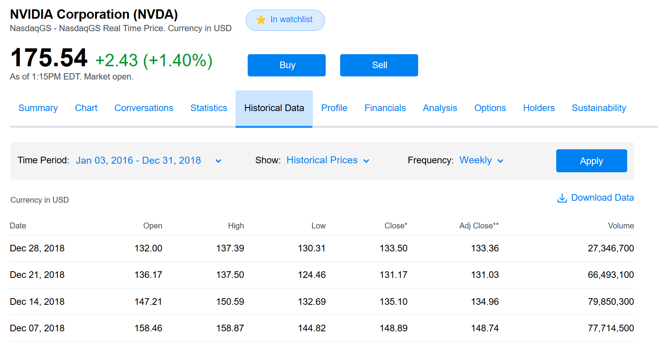

1. Statistics of NVIDIA weekly returns (Use SAS. Please submit SAS codes) (40 points)
2. Arithmetic mean
3. The 95th percentile
4. A 90% Winsorized mean, which one of the following statement is correct?______
5. Set the bottom 10 percent of values equal to the 10th percentile value.
6. Set the upper 5 percent of values equal to the 95 percentile value; Set the bottom 5 percent of values equal to the 5th percentile value.
7. discard the lowest 5% and the largest 5% of values.
8. discard the lowest 10% and the largest 10% of values.
9. None of the above.
10. For NVDA’s weekly returns, find ONE of the following two: either the 90% Winsorized mean; or the 90% trimmed mean.
11. Standard deviation
12. Median
13. Median absolute deviation
14. Semi-deviation

(use the definition from <https://www.investopedia.com/terms/s/semideviation.asp>)

The formula for semi-deviation is:

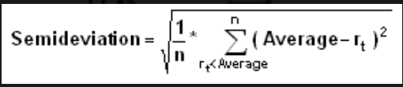

Where:

* *n* = the total number of observations below the mean (Different from the textbook’s definition)
* *rt* = the observed value
* *average* = the mean of a data set

1. The modal interval of the ten equally spaced grouped returns
2. Skewness:
3. Do NVDA’s weekly returns have a symmetrical distribution?
   1. Yes
   2. No
4. Consider the figures below. Which figure is more likely to represent NVDA’s weekly returns’ distribution?

A.

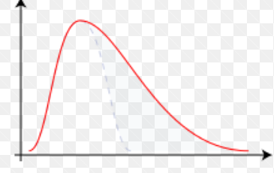

B.

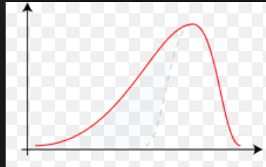

C.

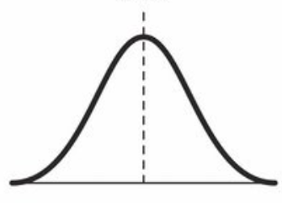

13) Kurtosis

14) NVDA’s weekly return’s distribution is a

A. leptokurtic

B. platykurtic

C. mesokurtic (identical to the normal distribution)

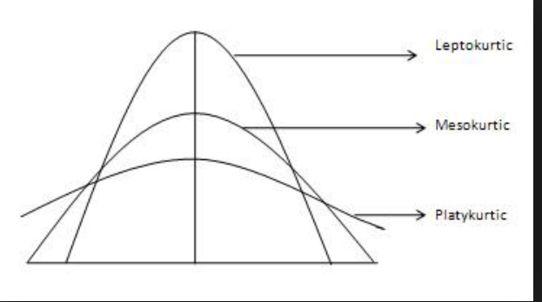

15) Does NVDA’s weekly return have a normal distribution? Briefly list three reasons (no more than 30 words)?

1. Comparison between NVDA and Russell 3000. (20 points)

The Russell 3000 Index is a capitalization-weighted stock market index, maintained by FTSE Russell, that seeks to be a benchmark of the entire U.S stock market ([Wikipedia](https://en.wikipedia.org/wiki/Russell_3000_Index))

Use the Russell 3000 Index’s weekly data from Yahoo Finance from 1/3/2016-12/31/2018. The screen shot of data download is as follows. The data is on SAS studio, Middle term exam.

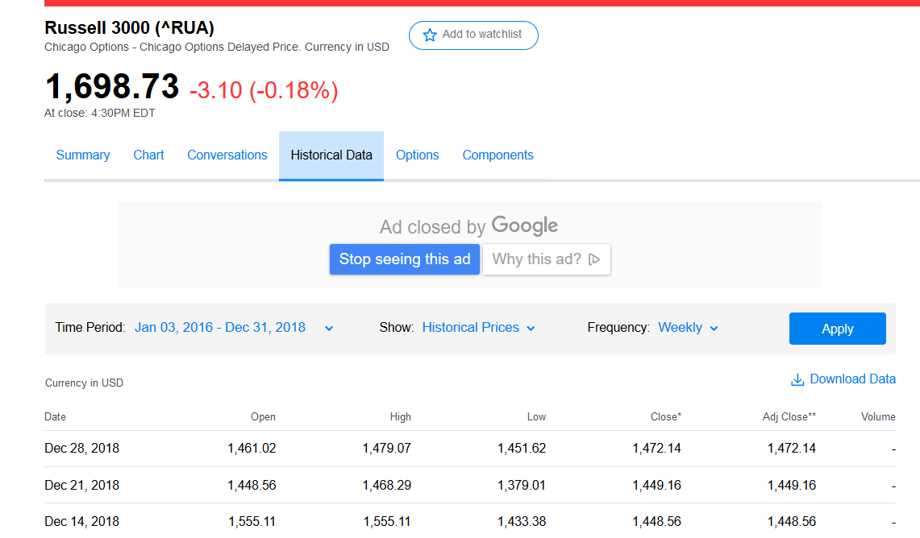

Use US 1-month T-bill rate to proxy for the risk free asset. The data is from <https://www.treasury.gov/resource-center/data-chart-center/interest-rates/Pages/TextView.aspx?data=yield>

The 1-month T-bill rate from 2016 to 2018 (quoted daily, percentage signs are omitted) is on SAS studio, Middle term exam.

1) You are a risk-averse investor. If the annual acceptance rate is 3%, please fill the table below.

|  |  |  |
| --- | --- | --- |
| 2016-2018 | Russell 3000 | NVIDIA |
| Weekly return’s mean |  |  |
| Weekly return’s standard deviation |  |  |
| Sharpe ratio |  |  |
| Safety first ratio |  |  |
| Probability of return less than the acceptable level |  |  |

2) Which one (Russell 3000 or NVIDIA) is more appealing to you and why. (Open question, no more than 80 words)?

1. NVDA CAPM (30 points)

Use the CAPM model:

Rit - Rft= αi + βi *(Rmt - Rft) +εit

One-month T-bill rate is a proxy for the risk free asset.

Russell 3000 is a proxy for the market portfolio.

1. Provide the following regressions:

|  |  |
| --- | --- |
| CAPM model | NVIDIA |
| Intercept |  |
| Intercept’s p value |  |
| Beta coefficient |  |
| Beta’s P value |  |

1. R square: __________. Briefly explain the statistical meaning of the r square. (less than 20 words)
2. Is NVIDA’s beta larger than 1, or less than 1? What is the economic meaning? (less than 20 words)
3. Does NVIDA have a statistically significant alpha? If yes, what is the economic meaning? (less than 20 words)

Yahoo Finance’s [beta](http://investexcel.net/calculate-stock-beta-with-excel/) is calculated from monthly price for the previous 36 months, relative to the S&P 500.

|  |  |
| --- | --- |
| Quote from Yahoo Finance (5/7/2019): Beta (3Y Monthly) of NVDA is | 2.28 |

1. Briefly list three reasons why your beta value is different from Yahoo Finance.
2. If I expect the market risk premium is 6% p.a. in 2019 and the risk free rate is 3% p.a. in 2019, use your regression estimate to find: NVDA’s annual return.